Childforms® I-CIFFHANGERINST
CLIFF HANGER WALL Assembly Instructions:
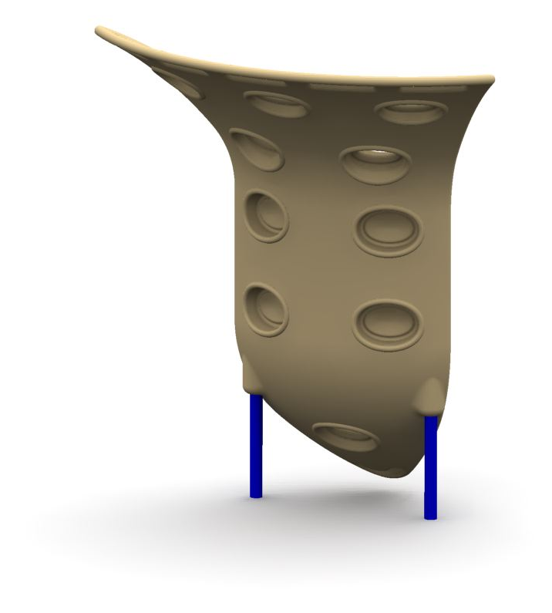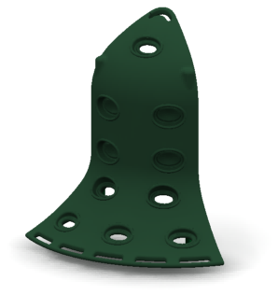
- Please read and follow all Safety Information.
- Please review assembly and component Diagrams.
- Verify component & hardware quantities received.
- Familiarize yourself with the installation procedures.

Safety
- Play site ground material should only be of an approved, shock-absorbing
type and meet minimum depth requirements. NEVER install playground equipment over paved or hard surfaces.
- Be sure that minimum fall zone requirements are met.
- Do not allow children to play on or near equipment which is in need of repair or replacement, is incomplete or is otherwise considered unsafe.

Parts Inventory and Set-Up
Confirm that all components, hardware and special tools are included (see Parts List).
Gather any addition tools necessary for installation (hex bit driver, level, tape measure, etc). Please follow diagrams and instructions in order.

- Site location and Preparation
Be sure site is of adequate size- allow for minimum fall zones (see Layout Diagram).
Be sure site is graded, level and free of debris for proper set-up and assembly..
Measure and mark site to determine Climbing Wall location and orientation.

- Assembly- General
Please use correct type and length fasteners as shown in the installation procedure.
Before setting Climbing Wall into footers, verify all hardware has been tightened.
Be sure to follow the assembly order to ease the construction procedure.

- Installation Procedure
After measurement and layout of site, carefully measure for footer locations.
Confirm footer locations- dig, pour and set footers and brace assembly in place.
PARTS LIST
Item Qty. Description Drawing Part Number
A (1) Cliff Hanger Plastic 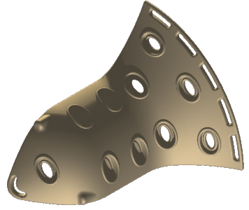 921-00001-T
B (2) Cliff Hanger Wall 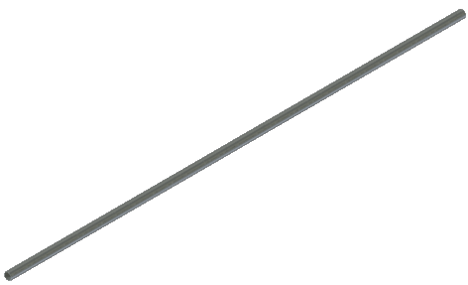 921-00002-B/G
Support Posts
C 2 Molded Climbing Wall 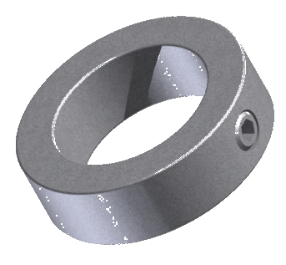 950-281-0005-02
Lock Collar
Hardware: 0-3.5INCLIFFHANGERHWKIT
Item Qty. Description Drawing Part Number
HA (8) Flat Washer 1”x.4”x.07” 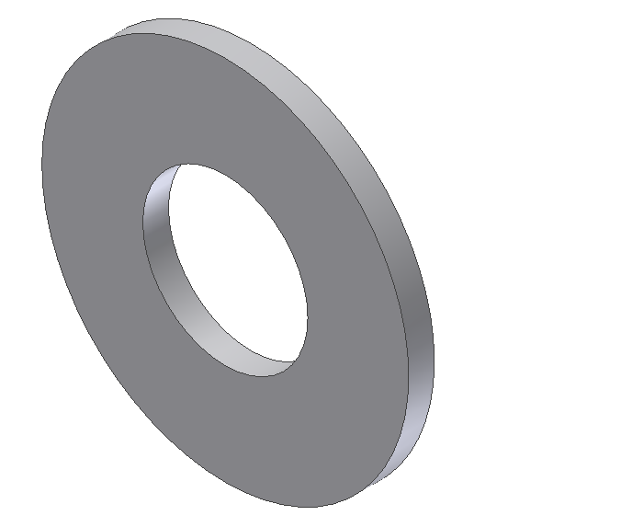 100-815FWSS
HB (8) 5/16-18 x 1.25” Torx Button Head Screw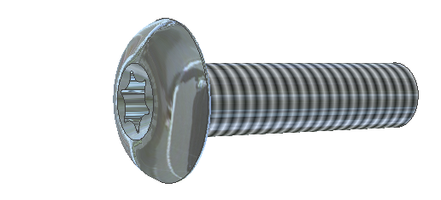 100-516114

Tools:
Item Qty. Description Drawing Part Number
TA (1) Torx Hex Bit T40 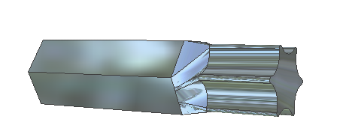 100-00T40

Installation Instructions

- Determine which way your cliff hanger wall will be oriented. Refer to photos on top of page 1. For the purposes of this guide one orientation is shown, however the same steps should be taken to install the cliff hanger the opposite way.

- Locate support post (B) mark with an “R”. Insert support post (B) mark with an “R” into hole in cliff hanger plastic (A) marked with an “R”. Making sure the end with two holes near the end of support post goes in first and is pushed to top of cliff hanger plastic.
Predrilled holes
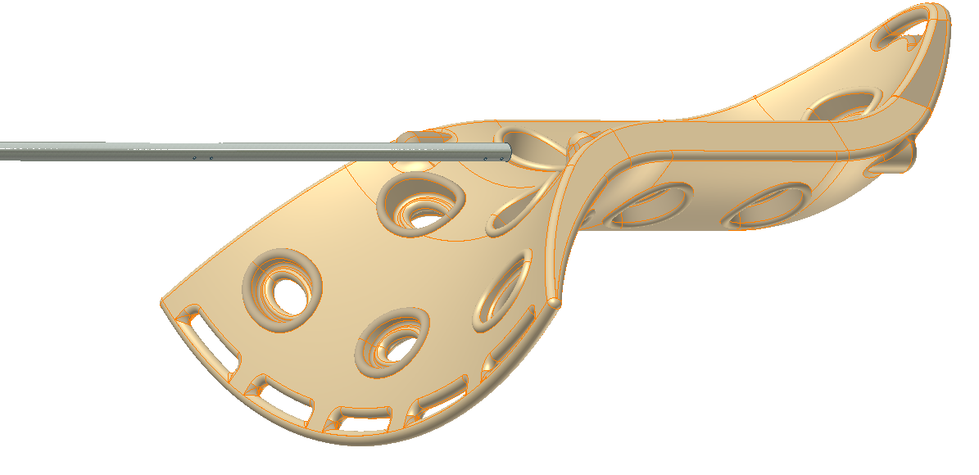
R
R
- Align the predrilled holes in the cliff hanger plastic (A) and threaded holes in support post (B) and attach using (1) washer (HA), and (1) 1 ¼” bolt per hole (HB).
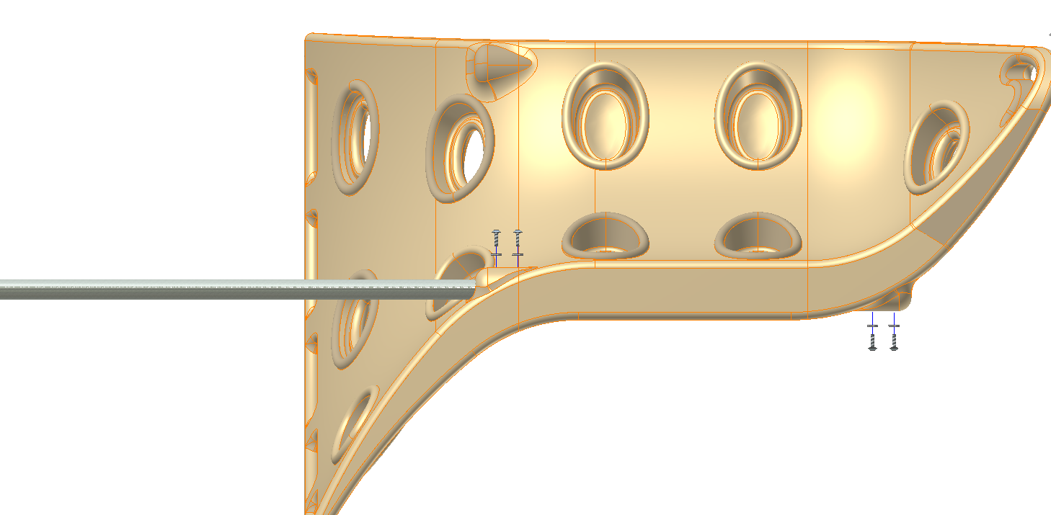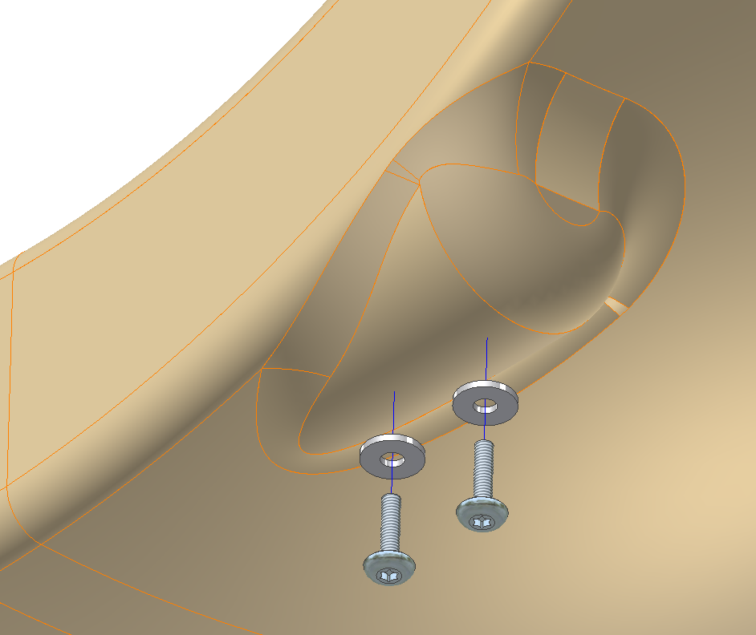

- Repeat step 1-2 for pole and hole marked “L”.

- When you are ready to place the climber into the ground, determine the location, measure and dig (2) holes approx. 18” diameter by 24” (min.) deep for each support post. Mix and pour concrete into holes, leaving concrete 2” below ground level. Lower the climber anchors into the concrete. Securely prop with wood or similar temporary Bracing structural material. Leave undisturbed for (3) days minimum until concrete has fully set. Finally, cover exposed concrete with dirt and tamp to ground level. Cover entire play area with an approved ground surfacing material.
Note: Be sure not to create any head/neck entrapments with the placement of the cliff hanger to the deck. Refer to ASTM 1487 for guidelines on placement.

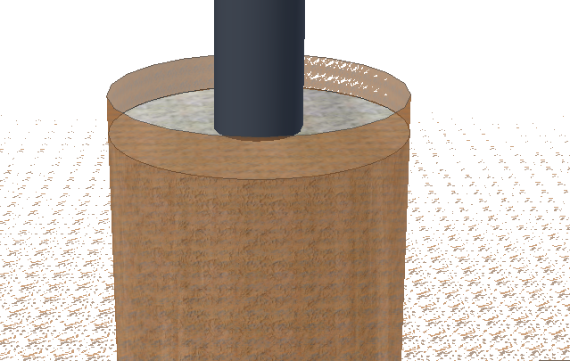
Note: When pouring concrete, leave 2” at top for tamped soil fill after concrete has set.

REV | ECO | DATE | BY | APRV
A |  | 8/18/14 | MA

