Large and Small Tree House

Place equipment on the ground as level as possible. Using the stakes provided and a 3lb. sledgehammer; drive the stakes into the ground completely until the top of the stake is not protruding up from the ground Repeat the same process for all places shown in the figure below.

Note: If installing a Large Tree House there will be footer (as shown in picture) that will be installed under the end of the slide.

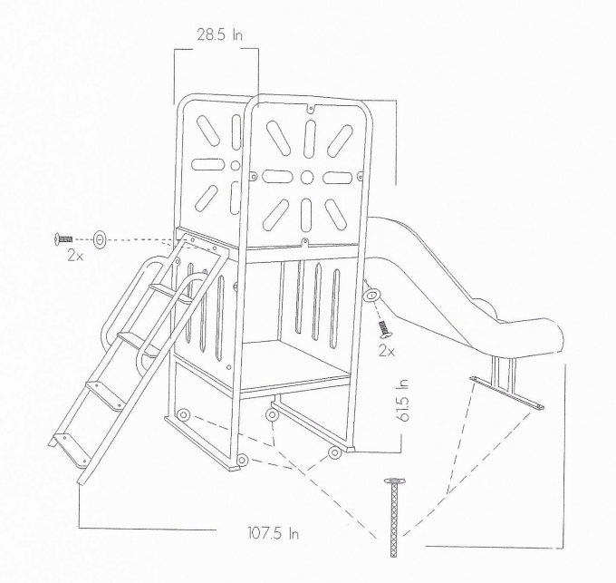
Large Tree House is shown below

